Local User Profiles

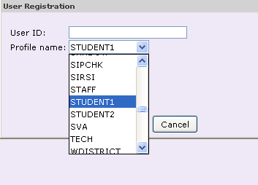
- Wherever you are asked for profile name, select from the drop down menu the correct profile.
User profiles for your school / district are as follows:
1

(EDIT AS NEEDED)

Patrons
STUDENT1 | XXXX STUDENT
STUDENT2 | XXXX STUDENT
STUDENT3 | XXXX STUDENT
FACULTY1 | XXXX FACULTY
FACULTY2 | XXXX FACULTY

Staff – Workflows only, no circulation
CIRC1 | Circulation Desk - Staff
CIRC2 | Circulation Desk - Substitute
LIB1 | Librarian - Supervisor
LIB2 | Library Staff

(ADD ALL USER PROFILES AND THEIR POLICIES)

User Profile Policies

Profile | Policy
Profile: FACULTY1  Loan Period/rule: XXXDays, xxRenewals, xxFines | Overdue threshold
 | Bill threshold
 | Checkout Limit
 | Hold Limit
Profile | Policy
Profile: FACULTY2  Loan Period/rule: XXXDays, xxRenewals, xxFines | Overdue threshold
 | Bill threshold
 | Checkout Limit
 | Hold Limit
Profile |  | Policy
Profile: STUDENT1  Loan Period/rule: XXXDays, xxRenewals, xxFines |  | Overdue threshold
 |  | Bill threshold
 |  | Checkout Limit
 |  | Hold Limit
Profile |  | Policy
Profile: STUDENT2  Loan Period/rule: XXXDays, xxRenewals, xxFines |  | Overdue threshold
 |  | Bill threshold
 |  | Checkout Limit
 |  | Hold Limit
Profile |  | Policy
Profile: STUDENT3  Loan Period/rule: XXXDays, xxRenewals, xxFines |  | Overdue threshold
 |  | Bill threshold
 |  | Checkout Limit
 |  | Hold Limit

