Staff User Assigned Privileges and Toolbars

Toolbars are assigned according to access privileges.

Assigned Toolbars: (ENTER INSTANCE STAFF ACCESS AND TOOLBARS)

BLDG - NAME - Toolbar - LIB1- login BLDG - NAME - Toolbar – LIB2 - login
BLDG – NAME - Toolbar – LIB3 - login BLDG - NAME - Toolbar – CIRC1 - login
BLDG - NAME - Toolbar – CIRC2 - login BLDG - NAME - Toolbar – CIRC3 - login

EX: KAHS – (librarian name) Toolbar – LIB1 login: ka_lastname pwd: KAHS
KAEL – Student Aide Toolbar - LIB3 login: kael_student pwd: KAEL
KAHS – Circulation Station Toolbar – CIRC1 login: kahs_circ pwd: KAHS

Toolbars are assigned according to access privileges. The toolbar that displays will be the toolbar assigned to the user login. Please click (to select) this toolbar the first time you login.
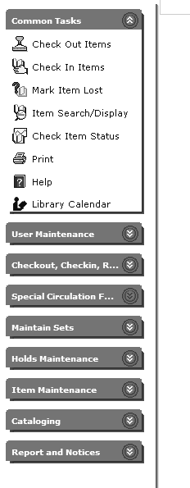

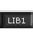

INFOhio Sirsi K-12 Staff Access Options

Common Tasks
Check Out Items
Check In Items
Mark Item Lost
Item Search/Display
Check Item Status
Print
Help
Library Calendar

User Maintenance
Display User
User Registration
Copy User
Modify User
Remove User
Suspend User
Unsuspend User

Item Search/Status
Item Search and Display
Check Item Status

Circulation (Checkout, Checkin, Renewals and Fines)
Check Out Items
Check In Items
Renew Single Item
Renew User Checkouts
Paying Bills
Billing a User
Credit User Account
Fine Free Check In

Special Circulation Functions
Bookdrop Check In
User Claims Returned
User Lost Card
Modify Due Dates
Mark Item Used
Ephemeral Checkout (for impermanent items; for counting purposes only; no record kept)
Inventory Item
Scanner
Pending Transits
Receive Items in Transit

Maintain Sets

Display Circulation Sets

Add Circulation Sets

Modify Circulation Sets

Remove Circulation Sets

Holds Maintenance
Place Hold
Display User Holds
Modify User Holds
Remove User Hold
Display Item Holds
Display Title Holds
Reorder Hold Queue
Modify Holds for Item
Remove Item Hold
Place Blanket Hold
Trap Holds

Item Maintenance
Add Brief Title
Add Item
Edit Item
Change Item ID
Mark Item Missing
Mark Item Lost
Remove Item

Cataloging
Add Title
Duplicate Title
Modify Title
Call Number and Item Maint.
Transfer Title/Call No/Items
Remove Item
Global Item Modify
SmartPort (Copy cataloging from CRC, LC, etc.)
MARC Export
Display Authority

Reports
Reports Session
Schedule New Reports
Scheduled Reports
Finished Reports

