Local Library Codes

1. Wherever you are asked for your library code, select your building code from the drop down menu.

(ADD LOCAL BUILDINGS AND BUILDING CODES)
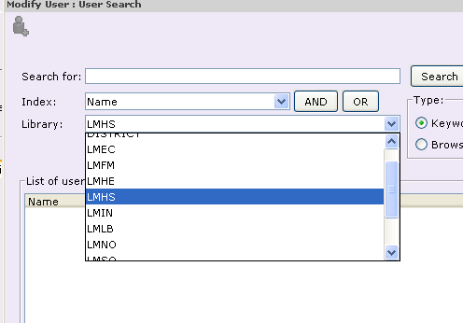
CODE – ___________High School

CODE – ___________Middle School

CODE – ___________ Elementary

1

Information to be entered per district/  building |  | * = CRD Compulsory Return Date |  |  | ** = library specific District yearly calendar
Name | Description | Loan Period | Accrue Fines | Days closed | Dates closed
DISTRICT | Name of district |  |  | Sat/Sun
(Gen Loc Code) | Name of school | *CRD | n | Sat/Sun | **
(Gen Loc Code) | Name of school | *CRD | n | Sat/Sun | **
(Gen Loc Code) | Name of school | *CRD | n | Sat/Sun | **
(Gen Loc Code) | Name of school | *CRD | n | Sat/Sun | **
(Gen Loc Code) | Name of school | *CRD | n | Sat/Sun | **
(Gen Loc Code) | Name of school | *CRD | n | Sat/Sun | **

